4.5 Triple Integrals

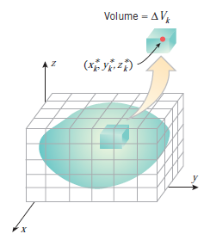
Motivation: Suppose we want to take an integral of a function of three variables, , over a rectangular box . There are several possible reasons for wanting to do this as we will see in this section.

Our strategy for doing this is analogous to what we did for double integrals. In particular we partition into l subintervals of length , we partition into m intervals of length , and we partition into n subintervals of length .
After this we have divided B into boxes with volume .

Definition: The triple integral of over the box B is
provided that the limit exists (where is a sample point in ).

Theorem (Fubini’s Theorem for Triple Integrals):
If is continuous on the rectangular box , then .

Note: The order of the differentials in the above theorem may be permuted as long as the limits of integration on each integral are changed as well.

Example 1:
- Suppose that B is a rectangular box. What is the geometrical meaning of the quantity ?
This triple integral yields the volume of the rectangular box B.

- Evaluate the triple integral exactly where .
By Fubini’s Theorem we have that

We can extend our discussion of triple integrals to more complicated regions of integration.
Definition: A solid region E is said to be of type 1 if it lies between the graphs of two continuous functions of x and y. That is, if where D is the projection of E onto the xy-plane.

Note: The projection of a solid E onto the xy-plane is the set . Projections onto the xz-plane and yz-plane are defined similarly. Intuitively, the projection of a solid E onto the xy-plane is the resulting two-dimensional region if the z coordinate of every point in E became 0.

Note: Type 2 and type 3 regions are defined similarly to the type 1 region. In type 2 regions x is bounded by functions of y and z, and in type 3 regions y is bounded by functions of x and z.

Type 1 Region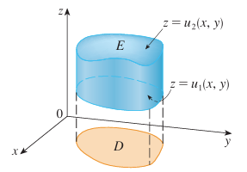 | Type 2 Region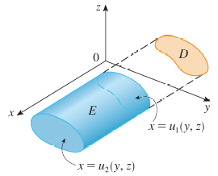 | Type 3 Region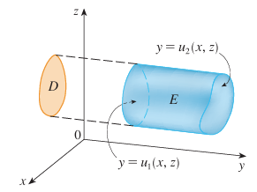

Extending the idea used in section 4.2 for double integrals, we get the following theorem.

Theorem: If E is a type one region: . Analogous results hold for type 2 and type 3 regions.

Note: A picture reflecting this theorem for Type 1, 2, & 3 regions are shown below.

Note: If D happens to be a two-dimensional type 1 or type 2 region, the above theorem makes it possible to evaluate triple integrals over regions more complicated than rectangular boxes.

We will now discuss a general procedure for setting up a triple integral as an iterated integral.

THE KEY TO GETTING GOOD AT SETTING UP TRIPLE INTEGRALS IS UNDERSTANDING THE GEOMETRY OF THE SITUATION AND THE INEQUALITIES INVOLVED.

Generally speaking, after we have the inequalities determining the region of integration and a picture of the region of integration, we follow one of the procedures below when setting up triple integrals for evaluation.
When working from a Picture of the Region of Integration:
- Determine if the region in question has a clear floor/ceiling (z-bounds), front/back (x-bounds), or left/right (y-bounds).

- Select one of these to be the innermost variable of integration and write down the appropriate bounds.

- Project the region of integration onto the appropriate plane. Draw a picture of the projection and write down the inequalities determining the projection.

- Set up the appropriate double integral (as an iterated integral) using the projection from 3.

When working with Inequalities describing the Region of Integration:
- Pick a variable to be the innermost variable of integration.

- Write down all the inequalities involving the variable chosen in 1. Choose the most restrictive inequalities for the upper and lower bound on the variable chosen in 1.

- Project the region of integration onto the appropriate plane. Draw a picture of the projection and write down the inequalities determining the projection (the inequalities determining the projection may always be deduced from the original inequalities).

- Set up the appropriate double integral (as an iterated integral) using the projection from 3.

Note: Both approaches have the same steps (3) & (4). The only difference is how we establish the bounds for the innermost variable of integration.

Note: In order to use second approach of working with inequalities you already need to have a sketch of the region and so, this can often times be more work than by just using the first approach.

Example 2: Evaluate where E is the solid tetrahedron bounded by four planes: , , , and .
First, we sketch a picture of E (shown at the right).

Steps (1) & (2):
Using a Picture of the Region of Integration
We see that the region has a clear “floor” (the xy-plane) and “ceiling” (the plane ).
Therefore, we create bounds .

Using Inequalities describing the Region of Integration
In terms of inequalities, we note that .
We choose z as our innermost variable of integration. We know from the inequalities that .

By either of the above approaches we now know that
where D is the projection of E onto the xy-plane.

Steps (3) & (4):
We now project the solid to the xy-plane and obtain the region D (shown at the right). We see that .
Therefore, we set up the following iterated integral:

We then calculate:

Note: There are actually six different ways that the above integral could be set up. For example if we would have started by bounding x we would get . Then, after examining the projection onto the xz-plane we could have obtained the iterated integral: which yields the same answer.
Example 3: Set up but do not evaluate an iterated integral (in rectangular and in the specified order) which will yield the volume of the solid E which is bounded by the quadric surface and the plane .

- Set up the iterated integral so the differentials are in the order .

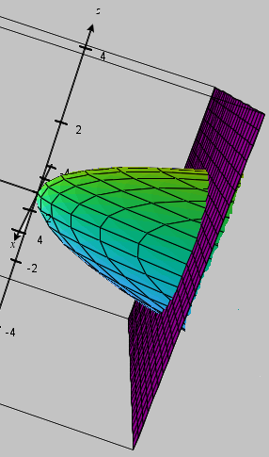
First, we sketch a picture of E (shown at the right).

Steps (1) & (2):
Using a Picture of the Region of Integration
We see that the region has a clear “left” (the surface given by ) and “right” (the plane ).
Therefore, we create bounds .

Using Inequalities describing the Region of Integration
In terms of inequalities, we note that .
We need to use y as our innermost variable of integration. We know from the inequalities that .

By either of the above approaches we now know that where D is the projection of E onto the xz-plane.

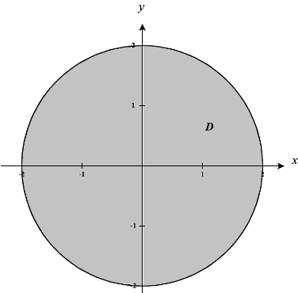
Steps (3) & (4):

We now project the solid to the xz-plane and obtain the region D (shown at the right). We see that .
Therefore, we set up the following iterated integral: .

- Set up the iterated integral so the differentials are in the order .

Steps (1) & (2):
Using a Picture of the Region of Integration
We see that the region has a clear “top” (the surface given by ) and “bottom” (the surface given by).
Therefore, we create bounds .

Using Inequalities describing the Region of Integration
In terms of inequalities, we note that .
We note that the only inequality restricting z is , and we see that: .

By either of the above approaches we now know that
Steps (3) & (4):

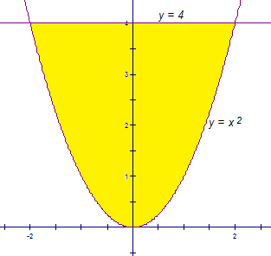
We now project the solid to the xy-plane and obtain the region D (shown at the right).
We see that .

Therefore, we set up the following iterated integral

Example 4: Consider the iterated integral . Rewrite this iterated integral so that the differentials are in the order: .
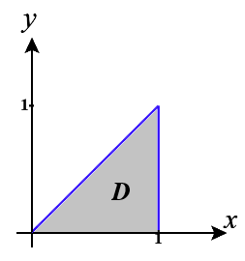
First, we note immediately from the given iterated integral that the region of integration is: . Moreover, the projection of E onto the xy-plane is: (picture shown at the right).

Using a Picture of the Region of Integration
Steps (1) & (2):
We don’t have a picture of the full region. We will construct a picture of this region by building off the projection region of D. We start by sketching a picture of D in 3-space within the xy-plane. We will think of this as the “foundation” of the solid that we are constructing. Based on the inequalities that we described above we know that in our region . This tells us about how the “floor” and “ceiling” of our region behave. We see that the “floor” of our region is constantly at , whereas the “ceiling” of the region changes heights and is given by the plane .
Since acts as the “floor” of our region we know that the region of D that we have sketched is the “floor” of our solid.
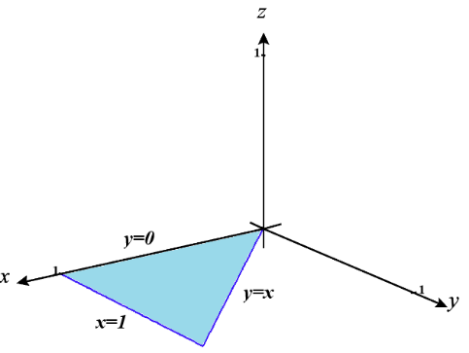
To better understand the effects of the “ceiling” on our region, we will move along the edges of the region D and attempt “reach up” to touch the ceiling at every point.

As we walk along the edge where we note that since , then the “ceiling” of the region along this edge would also have to be .

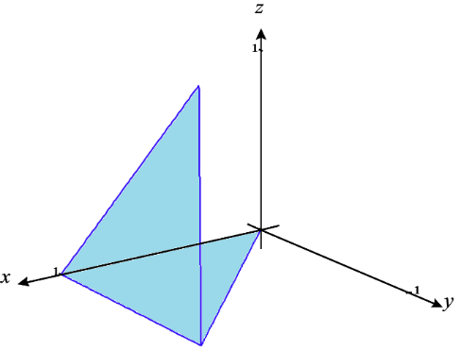

As we walk along the edge where , we note that y ranges from 0 to 1 along this edge and so the “ceiling” here increases from a height of 0 to 1. We also note that the increase from a height of 0 to 1 is done so linearly since represents a function with linear growth. This allows us to create the following updated sketch of E.

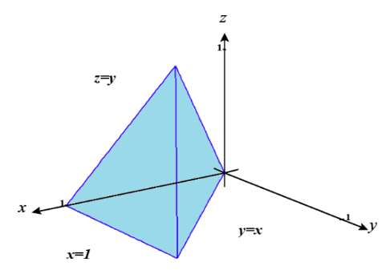

As we walk along the edge of , we note that y again ranges from 0 to 1 and so the “ceiling” here increases from a height of 0 to 1. We again note that this increase in completed linearly since represents a function of linear growth. This allows us to create the final following updated sketch of E. Note that we have also been able to label each of the surfaces that make up the sides of E.

We can now see that the region has a clear “left” (the plane ) and “right” (the plane ).
Therefore, we create bounds .

So, we have for some region B that is the projection of E into the xz-plane.
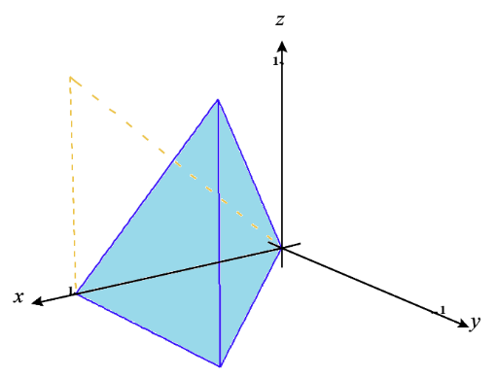
Steps (3) & (4):
Now we need to project E into the xz-plane and find the region B.
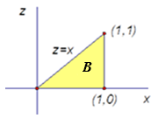
We know that .
Therefore, we set up the following iterated integral

Using Inequalities describing the Region of Integration
Steps (1) & (2):
We know we want the differentials of our new iterated integral to be in the order: . This means we first need to find restrictions on y which may depend on x and/or z. Looking at the inequalities involving y in . We see that we have , , , and. Looking at the other inequalities in E, we see that . Thus, the most restrictive bounds on y would be .

So, we have for some region B that is the projection of E into the xz-plane.

Steps (3) & (4):

Now we need to understand the projection of E into the xz-plane. When we are in the xz-plane we know that y no longer exists (or can be thought of as ). Therefore, the inequalities describing our region become . Since we want bounds on z first we choose the most restrictive inequalities of . Then since we want bounds on x last we choose the least restrictive inequalities of . This tells us that our region B is .

Therefore, we set up the following iterated integral

